Aetherfall Instructions

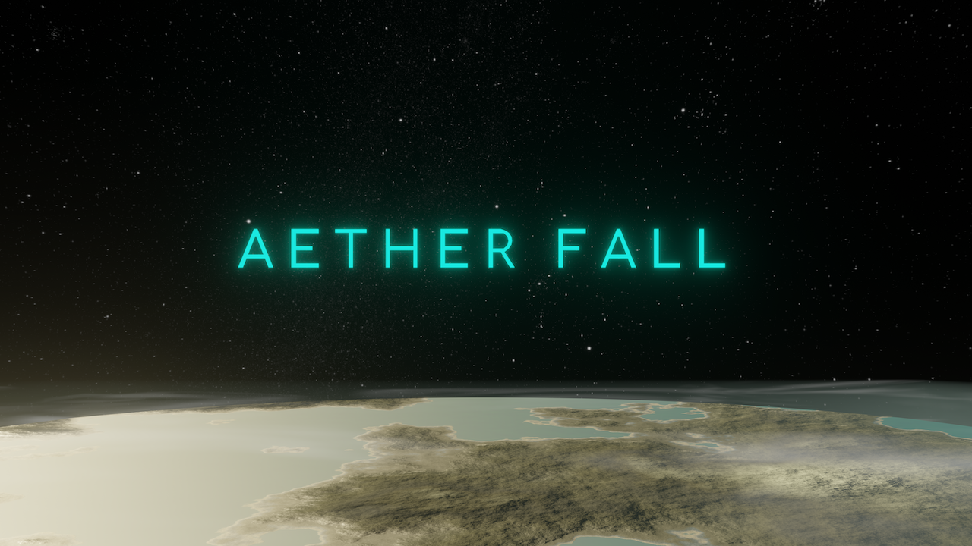

1. Summary
The goal of the game is to conquer the galaxy. This is done by taking individual sectors of the galaxy at a time. Sectors are made up of a number of planets. Battles are fought on the surface of these planets, in the form of turn based tactical gameplay.

2. Menu
On the startup screen, clicking play will start a new game and take you to the galaxy map. There are options for Settings, Credits, and to Quit the game as well.

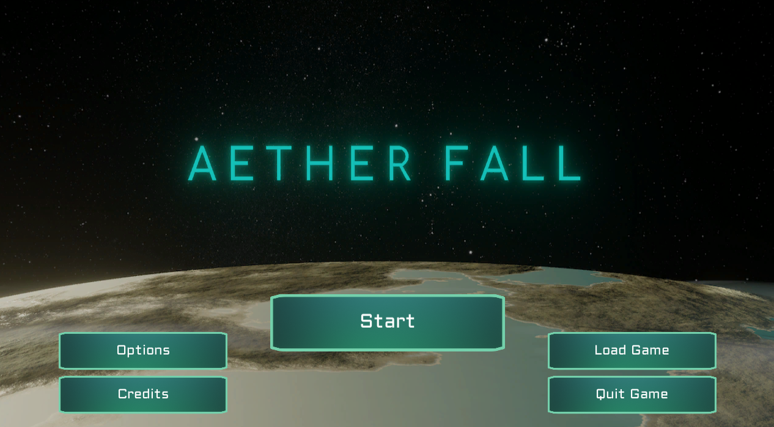

3. Galaxy Map
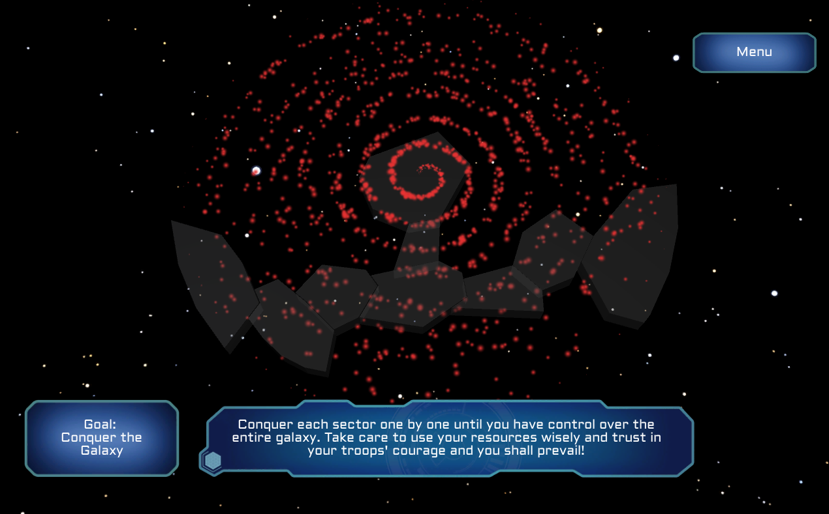
Controls
- Arrow Keys Select a route
- Enter Move ship to next planet
- Escape Key Pause
- Left Click Action (select planet)

Upon starting the game, the galaxy will come into view. Clicking on a sector will zoom into that sector. When just starting up, only the first sector (leftmost) will be available to navigate through; the rest will be hidden.
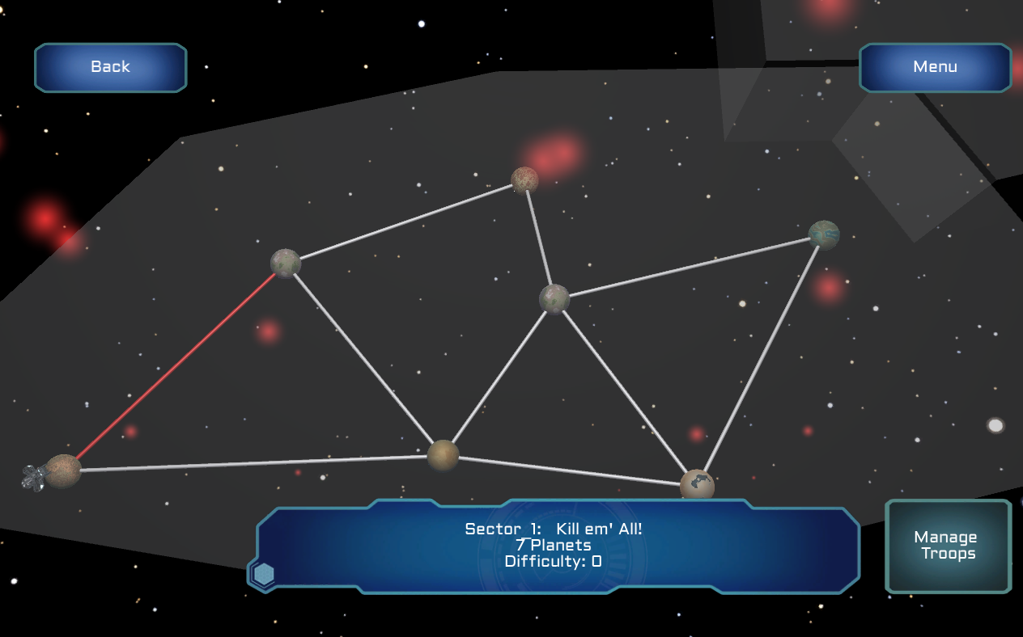
There are three types of planets in each sector: Controlled, Contested, and the Enemy Sector Capital. The goal is to capture the Enemy Sector Capital, which allows the player to advance to the next sector. Contested planets must be captured before the player can advance in the sector. However, not all planets need to be captured, the player only needs to clear a path to the Enemy Sector Capital, any other planets offer bonuses and are optional.

The player’s ship will spawn at the player’s initial planet. Clicking on the ship will activate that ship. Use the arrow keys to cycle through available routes, and press enter to move along the selected route to the next planet. To move onto the next Sector (assuming you captured the Enemy Sector Capital), click on the next Sector.
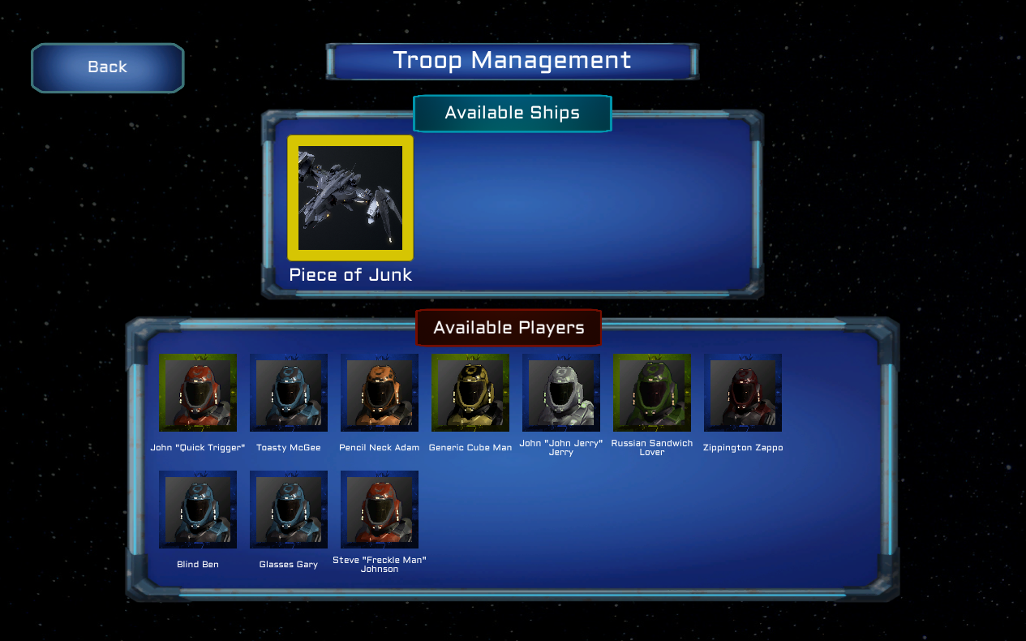
Clicking the troop management button (found in the Sector Overview) will bring up the Troop Management Window. Here, the player can assign individual units to a ship. To start, click the ship you wish to assign units to (It will highlight yellow). Then, click a unit to open up the Unit Preview Window. Click the Select button to add that unit to the ship; click Remove to remove that unit from the ship. Selected units will be outlined in yellow. Clicking the Back button at any time will return to the previous screen.
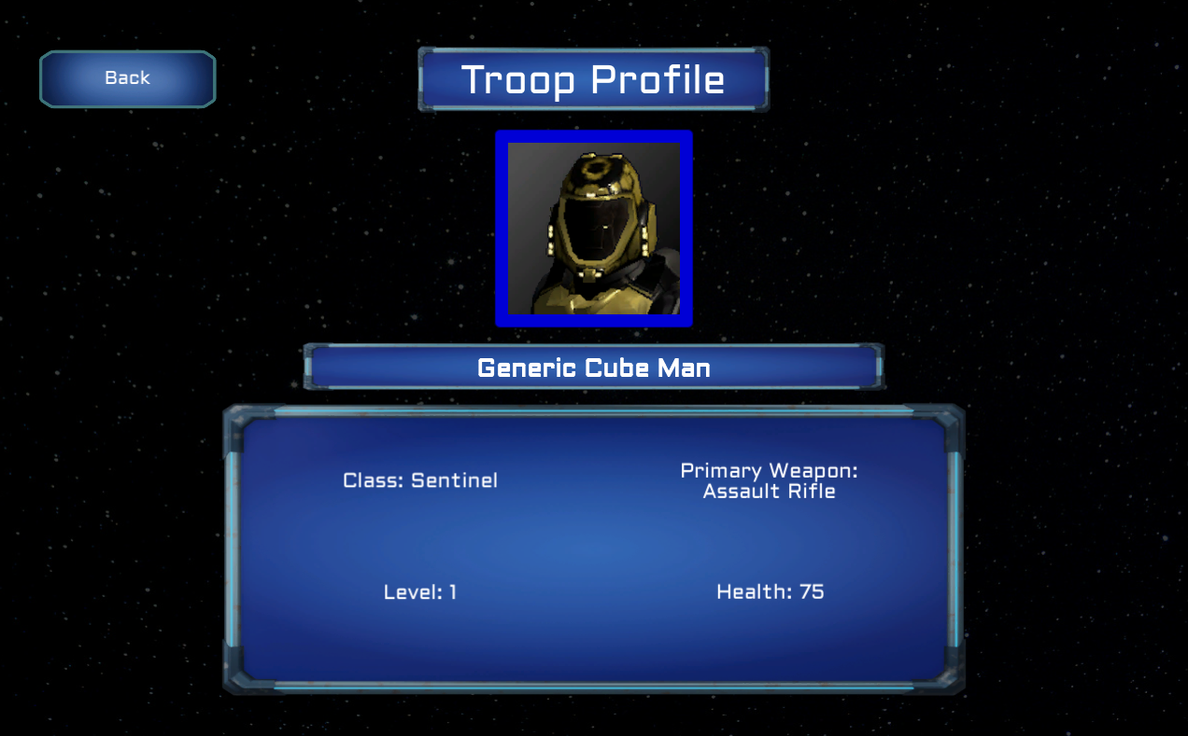
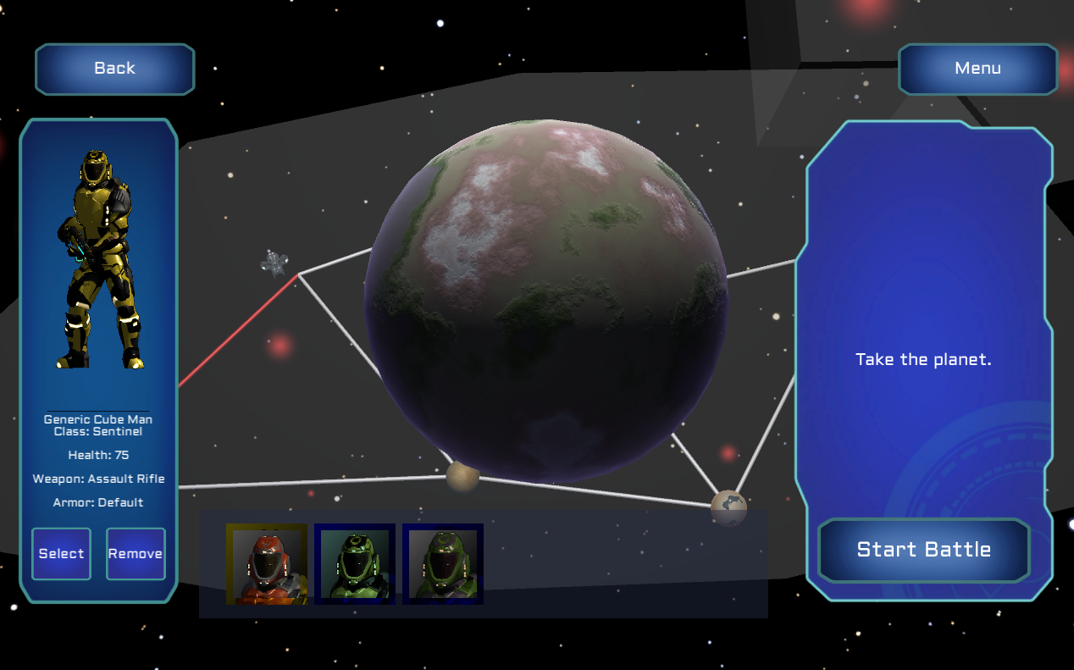
Clicking a planet will bring up details about that planet. Clicking the planet your ship is at will bring up the Battle Selection Window. Here, all units on the active ship will appear on the bottom. Clicking a unit and then the Select button will choose to send that unit to the battle (It will highlight yellow). Clicking a unit and then the Remove button will no longer send that unit to the battle. Clicking the Start Battle button sends the units to the Battle Map.
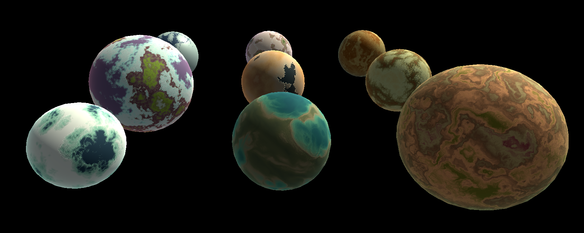

4. Battle Map

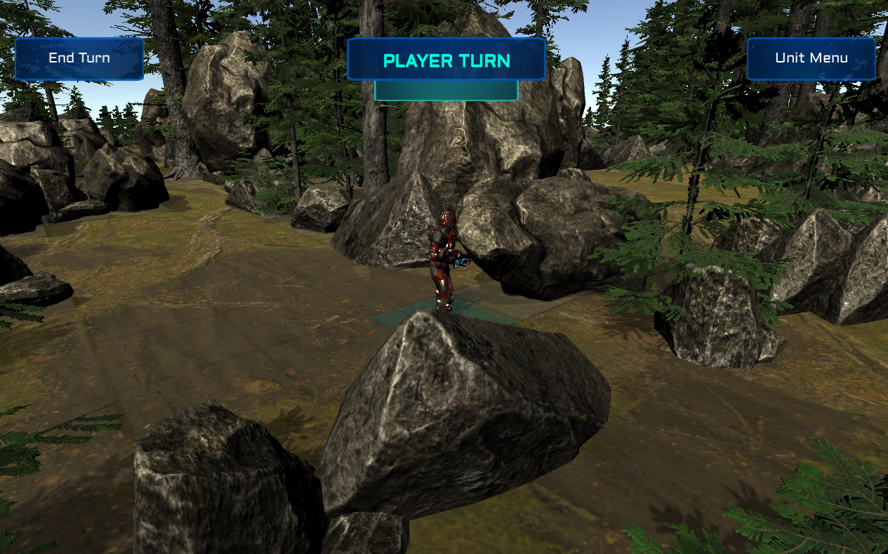

Controls
- Left Click Action
- Arrow Keys Move camera
- WASD Rotate Camera
- Escape Key Pause
- M Unit Menu

On the planet, the goal is to kill all of the enemy units while keeping your units as safe as possible. Any of your units that is damaged or killed will carry over from battle to battle. Winning planet battles can replenish your troops, give you better weapons, and more.

A battle starts on the player's turn. Each turn, each unit can do each, moving, attacking, and using an ability, once. Left click on a character to select it. There is an edge that shows the max movement range, a blue highlighting which shows the range of the player’s weapon, and a path that occurs as you hover over tiles. Left clicking a tile will ask the player for confirmation to move to the indicated tile. Clicking Confirm will move the player, and clicking back will not. A character can only move once per turn, even if the character did not go the full distance that it could go.
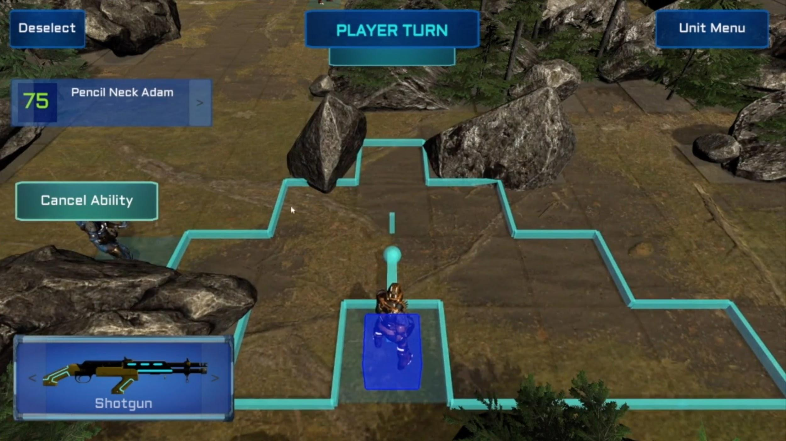

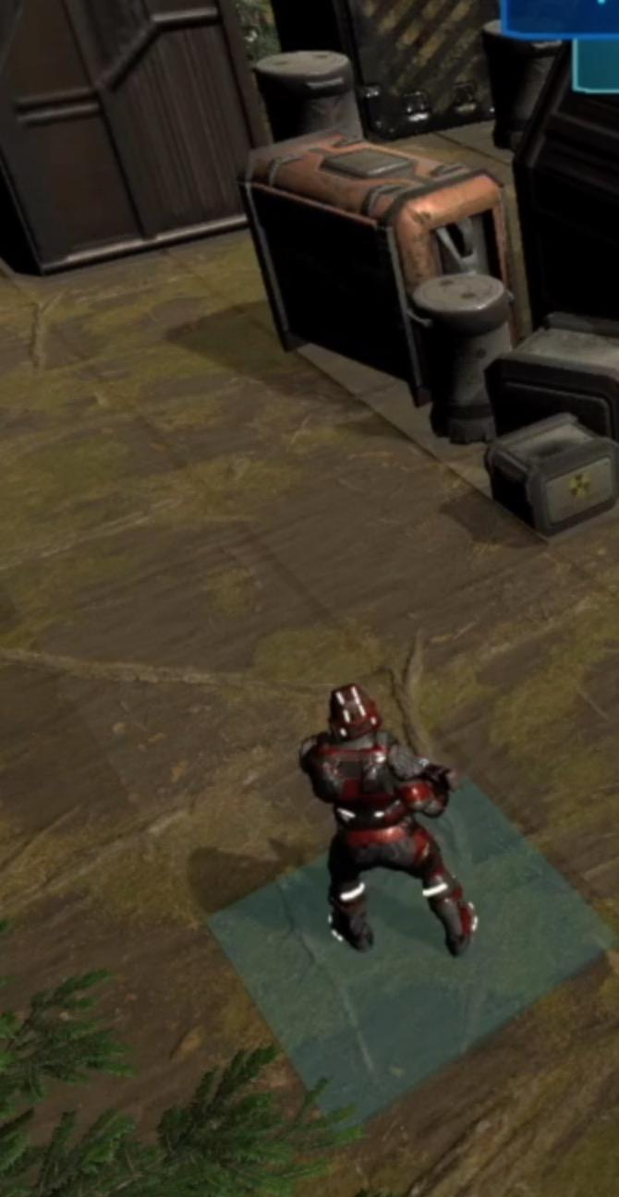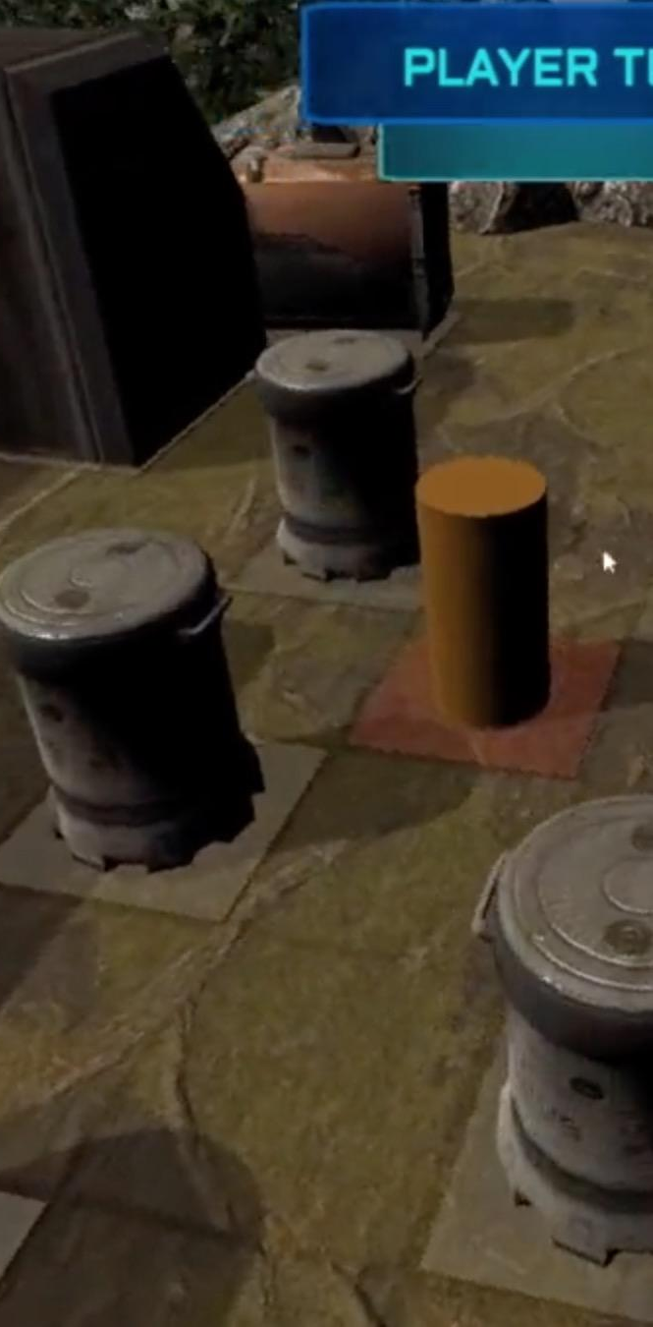
Tile States
- Player Blue
- Enemy Red
- Obstacle White
- Unoccupied Clear

A character can only move to Open tiles and cannot move through enemies or other player controlled characters. Pressing H will hide the grid tiles. Pressing H again will restore the grid tiles.

While a character is selected, there are arrows on the bottom left of the screen. Pressing them will cycle to your next character. There is a weapon preview as well, with arrows next to it. Pressing them will cycle to the next weapon. Finally, there is a Unit Menu button that, when clicking it (or pressing M) will bring up the Unit Menu Screen.

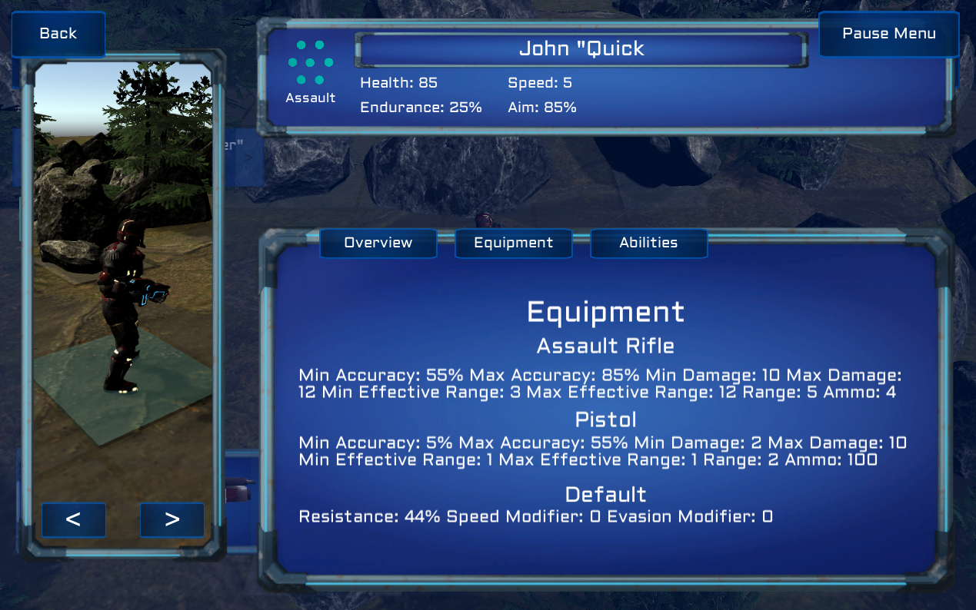

In the Unit Menu, you can see stats about the character, the character’s weapon, and the character’s ability here and by pressing the different tabs for each. There are arrows here, allowing you to switch the character without ever leaving the unit menu. Finally, you can rotate the character by clicking and dragging the character in the preview window here, too.
To attack an enemy, when your character is selected, click on an enemy. If the enemy is in range, your weapon has sufficient ammo (Pistols are unlimited), and there is no obstacle in the way, the attack preview screen will appear. This will give you detailed information about your attack. Pressing the Attack Button in the center will commence with the attack. Pressing cancel will return you to the selected player view.

The Ability button appears for all selected characters except for the Heavy class, who has a passive ability. Pressing the Ability button will bring up an Ability Active pop up on the screen and will allow you to use that class’s ability. An ability can be used once per battle per character.
Abilities
Dash
Pressing the Ability button gives you an extra movement during that turn.
Double Attack
Pressing the Ability button gives you an extra attack during that turn.
Deployable Cover
After pressing the Ability button, clicking on any open tile will place an object that lasts for 3 turns. The object cannot be shot through or moved through. It will destroy itself after the player’s third turn.
Med Pack
After the Ability button is clicked, clicking on another player unit will heal up to 30 Health, but not over that character’s maximum Health.
Teleport
After the Ability button is clicked, clicking on an open tile will teleport the character to that tile.
Headshot
After the Ability button is clicked, clicking on an enemy in the attack range of the current weapon, and not blocked by any object will bring up the Attack Preview screen. This ability grants extra damage, at a lower accuracy. Pressing Headshot! will trigger this ability attack.
Defy Death (Passive Ability)
When the character drops to 0 Health, it will restore to ¼ of Maximum Health to continue on fighting. No action needs to be taken by the player to click this ability.

Once the player is finished with all of their actions, or they do not want to take all of their actions and press the End Turn button, the player’s turn will end and the AI will be in control. The player’s turn will be restored after the AI turn is finished, and the camera will return to one of the player’s characters.

If all enemy players are killed, the battle is won, the planet is taken, and the player returns to the Galaxy Map. If all player characters are killed, the battle is lost, and the player returns to the Galaxy Map, with their characters dead.

